Lombard 7th Grade Volleyball Team
Head Coach: Traci Sharp
ASsistant Coach: Libby Rogers
- Riley Jenkins
- Brooklyn Ryden
- Surprise Mikonga
- Lily Hudgins
- Emma Nelson
- Libby Campbell
- Katelyn Engel
- Leigha Schisler
- Victoria Plue
- Alyssa Vetter
- Kacie Erwin
- Mollie Young
- Madison Behrens
18. Casey Folger
Athletic Director: Nick Young
Dean Of Students: Debbie Cratty
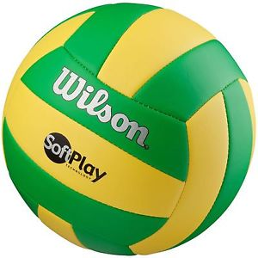
Principal: Nick Sutton
#Wearelombard #Galesburgpride

