Lombard Middle School
7th Grade Team Handbook
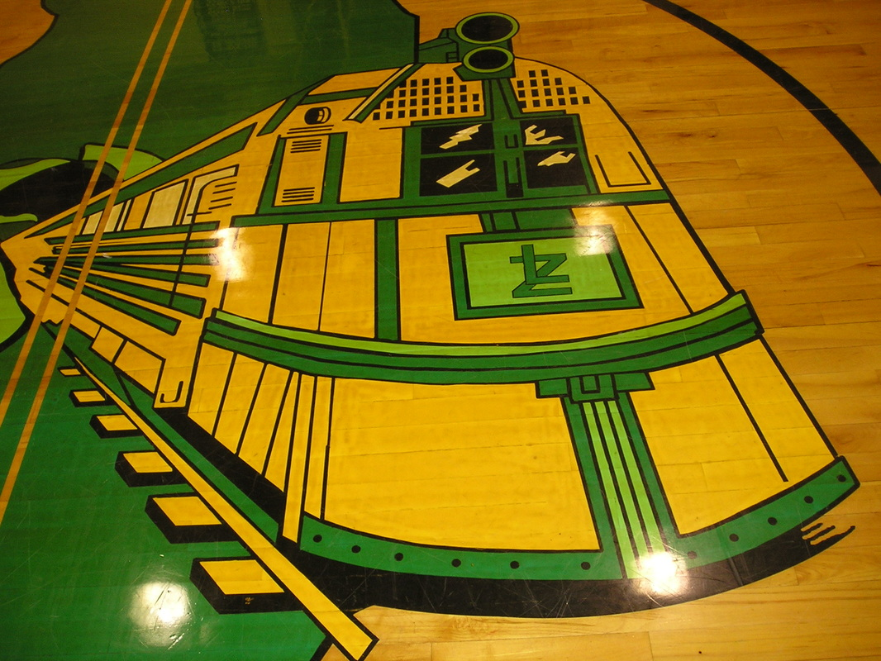
Pride Guide
7th Grade Teachers
Mrs. Sandstrom Ms. Elliott
Mr. Meyer Ms. Slaton
Ms. Weech Mrs. Scoggin
Miss Robinson Mr. Carpenter

Students are expected to follow the school-wide expectations throughout 8th grade. These expectations are called the Pride Guide.
Be Respectful
Be Responsible
Be There; Be Ready
KHFOOTY (Keep Hands, Feet, and Other Objects to Yourself)
Skyward Family Access
Skyward is an online gradebook and communication system used by District 205 schools. It is imperative that parents and guardians sign up for access to this program through the school office. With Skyward, you may:
- Track the progress of your student.
- Communicate with teachers.
- Receive information that is happening at your student’s school.
- Add money to the student’s lunch account
- Register for school
Teacher Communication
Teachers can respond to e-mail throughout the school day. It is often the best way to get ahold of a teacher. If you would like to contact a teacher via phone, the 7th grade teacher’s planning period is from 11:00 – 11:45 or 12:15 – 1:00. The office phone number is (309) 973-2004. This would also be the timeframe to schedule a meeting with the team of teachers throughout the year. Teachers are also available before or after school upon appointment.
Teacher | E-mail
Mr. Carpenter | ccarpenter@galesburg205.org
Ms. Elliott | celliott@galesburg205.org
Ms. Slaton | bslaton@galesburg205.org
Mr. Meyer | mmeyer@galesburg205.org
Miss Robinson | krobinson@galesburg205.org
Mrs. Sandstrom | bsandstrom@galesburg205.org
Mrs. Scoggin | sscoggin@galesburg205.org
Ms. Weech | lweech@galesburg205.org
Important Links
Website | URL | Purpose
Lombard’s school website and the 7th grade team homework blog | www.lombard205.weebly.com | School news, daily announcements, lunch menus, sports schedules, and much, much more!
Galesburg 205’s district website | www.galesburg205.org | District calendar and news, Skyward access links, and more
Common Core Standards | www.corestandards.org | Information about the common core standards

SUCCESS Program
After school on Tuesdays, Wednesdays, and Thursdays, students are given the opportunity to access 1 hour of tutoring and homework help. This program runs from 3:00 to 4:00. Staffed by teachers, it is a great place to get work done before going home or to ask questions on confusing assignments. Students are issued a pass with the time and date when they leave SUCCESS each day. Some 7th grade teachers offer extra credit when these passes are turned in.
Sports/Eligibility
7th grade students are often involved in a variety of sports! Eligibility is submitted by teachers each week on Thursdays. Students who are earning a failing grade in one or more classes will not be permitted to participate in their sport. They may be required to attend SUCCESS.
Teacher Policies and Procedures
Each 7th grade teacher has policies and procedures unique to their own classroom. Throughout the year, these do occasionally change based on the needs of individual students or classes. However, the teachers have attempted to give you a bit of an insight into what you can your student can expect in their classroom. The overviews that follow should be looked at as a guideline and is only meant to give you an idea of how each teacher runs his or her classroom.

Teacher Policies and Procedures

Teacher:  Ms. Elliott | Courses Taught:  Accelerated L. Arts and L. Arts
Phone: (309) 973-2004 | E-mail: celliott@galesburg205.org
General Homework Procedures:
Any work that is not completed in class will be assigned as homework unless otherwise noted. All homework assignments will be listed on my weekly blog and website. Homework is collected from each student at the beginning of each class period. Typically, homework is also assigned on Tuesdays and Thursdays, but it can vary. Longer projects and written assignments may have a posted due date that is over an extended period.
Missing/Late Assignment Policy:  Late homework will result in a loss of points for each day it is late. Remember, turning in homework late is better than not turning it in at all. I issue students 1 homework pass each quarter. | Absent Work Procedures:  After returning to class from an absence, it is the student’s responsibility to check his/ her ELA folder for work that may have been missed. S/he has the same number of days to make up work as days that were absent per the Student Code of Conduct.
Skyward Usage:
The points that students earn for each assessment are entered almost daily. An * means has not been graded. A zero means the assignment is missing. Be sure to read any comments in the grade book for explanations for any entries. Grades are printed on paper weekly and posted for students to check the grade for each class using his or her student ID number. Typically, grades are posted by 8:00 AM Thursday each week for eligibility.

Class Start Procedures:  Students will be given a short assignment as they enter the room daily. It is vital that students arrive to class on time in order to complete them. These assignments are to practice standards or skills. | Tardy Policy:  Students can earn rewards for being to school on time as defined by in their seats at the 8:04 tardy bell. We spell out various words with a letter earned for each day we have perfect attendance. A student is chosen from each grade level every week for perfect attendance as well. The first tardy to class is a verbal warning. The second tardy is 20 minute after school detention. The third and fourth tardy to class is an office detention. The fifth and sixth ones are I.S.S.P. Any additional tardy to any class will result in additional consequences. The data is collected for each quarter.
Other Policies, Procedures, and Expectations:
My classroom expectations are: Be Respectful, Be Responsible, Be There; Be Ready and K.H.F.O.O.T.Y. Each expectation is taught and practiced during the first week of school. Students can be selected for the Respect Wall for Random Acts of Kindness as well as following the PBIS expectations. Blue tickets are also rewarded for appropriate behavior and decision making.

Teacher Policies and Procedures

Teacher:  Mrs. Sandstrom | Courses Taught:7th grade  Life Science and Language Arts
Phone:  (309) 973-2616 | E-mail: bsandstrom@galesburg205.org
General Homework Procedures:
Any work that is not completed in class will be assigned as homework unless otherwise noted. All homework assignments will be listed on my weekly blog and remind 101daily text messages. Information on how to sign up for Remind 101 will be given to students during the first week of school. Homework is collected from each student at the beginning of each class period.
Missing/Late Assignment Policy:  Late homework will be lowered a letter grade for each day that it is late. Remember turning in homework late is better than not turning it in at all. | Absent Work Procedures:  After returning to class from an absence, it is the student’s responsibility to check the file for work with his or her name on it that may have been missed. S/he has the same number of days to make up work as days that were absent per the Student Code of Conduct.
Skyward Usage:
The points that students earn for each assessment are entered almost daily. An * means has not been graded. A zero means the assignment is missing. Be sure to read any comments in the grade book for explanations for any entries. Grades are printed on paper weekly and posted for students to check the grade for each class using his or her student ID number.
Class Start Procedures:  Students will be given a short assignment as they enter the room daily. It is vital that students arrive to class on time in order to complete them. | Tardy Policy:  The first tardy to class is a verbal warning. The second tardy is 20 minute after school detention. The third and fourth tardy to class is an office detention. The fifth and sixth ones are I.S.S.P. Any additional tardy to any class will result in additional consequences. The data is collected for each quarter.
Discipline Plan:
My classroom expectations are: Be Respectful, Be Responsible, Be There; Be Ready and K.H.F.O.O.T.Y. Each expectation is taught and practiced during the first week of school.
A score board is visually displayed for each class and points are earned for whole brain teaching.

Teacher Policies and Procedures

Teachers:  - Robinson  - Weech  - Meyer | Courses Taught:  - 7th Grade World Geography
Phone:  - (309) 973-2004 | E-mail:  - krobinson@galesburg205.org  - lweech@galesburg205.org  - jmeyer@galesburg205.org
General Homework Procedures:
- Homework may be assigned Monday, Tuesday, or Thursday.
- Homework is never assigned homework on Wednesday or Friday.
- Time is given in class to start the work, but it is usually an extension of the topic studied that day. New material is never assigned as homework.
Missing/Late Assignment Policy:  - File folders by period have make-up work inside with student’s name.  - It is the student’s responsibility to check and complete the work.  - Late work is accepted for the first 3 quarters and has 1 letter grade deducted for each day it is late.  - During the 4th quarter, late work is not accepted. | Absent Work Procedures:  - Student checks work agenda near the door that states what was done each day in class.  - Student should check the make-up folder for worksheets.  - It is the student’s responsibility to check, complete, and turn in.
Skyward Usage:
- Grades are entered as soon as the work is graded, which is usually daily.
- Students may ask to see their grade at any time, when appropriate.
- Lessons are put on the school 7th Grade web site on Thursday or Friday for the following week.
Class Start Procedures:  - The teacher meets students at the door and hands them a class start that is either a review from the day before or to gain prior knowledge for upcoming lesson. | Tardy Policy:  - When the door closes, class begins and students should be working on the class start quietly.
Discipline Plan:
- Discipline depends on the severity of the issue and if it is chronic or not.
- Some consequences may include a warning, one on one conversation, detention, or an O.D.R. in which the student is sent to the office.
Other Policies, Procedures, and Expectations:
- See attached syllabus and Survival Guide for additional information.

Teacher Policies and Procedures

Teacher:  - Justin Meyer | Courses Taught:  - English, Math, Science, Social Studies
Phone:  - (309) 973-2622 | E-mail:  - jmeyer@galesburg205.org
General Homework Procedures:
- Any work that is not completed in class will be assigned as homework, unless otherwise noted. Students will be made well aware of all homework assignments in advance of the due date.
Missing/Late Assignment Policy:  - If an assignment is late, points will be deducted accordingly to the amount of time it was late. | Absent Work Procedures:  - When a student returns to class from an absence, the student needs to ask for work they missed.  - Students will have the same number of days in which they were absent in order to make up the work.
Skyward Usage:
- All grades are updated weekly on Skyward. If a student has an * by an assignment, it is in the process of being graded.
- Students receive an update of their current grade every Monday at the start of class.
Class Start Procedures:  - Class begins with a short assignment. It is essential for students to arrive to class on time in order to complete and receive points for these assignments. | Tardy Policy:  - A student will be allowed three tardies per quarter. If they are tardy more than three times, they will receive a fair consequence depending on the number of times they have been tardy.
Discipline Plan:
- Students will be expected to behave appropriately in order to promote an environment conducive to learning.
- My classroom rules are “Be Respectful, Be Responsible, Be There; Be Ready, and K.H.F.O.O.T.Y.”
- Students will be expected to follow school policies, as well as classroom rules. If a situation arises, necessary and appropriate action will be taken to ensure minimal disruption in the learning environment.
Other Policies, Procedures, and Expectations:
- Daily targets and goals for the class are posted on the board and discussed at the beginning of each class.
- When applicable, students will be given an assignment at the end of class to gauge their understanding of the material covered during the class period.

Teacher Policies and Procedures

Teacher:  Mr. Carpenter | Courses Taught:  Life Science
Phone:  309-973-2617 | E-mail:  ccarpenter@galesburg205.org
General Homework Procedures:

Homework is counted as a part of the participation in the class. Student will be given a colored stamp the day homework is due. “A+ or 100%” means full credit INCOMPLETE= not completed LATE stamp signifies homework was turned in late. Students start the year being given 2 days to turn in work and as the year progresses expectations are raised. 4th Quarter no late work will be excepted.
Missing/Late Assignment Policy:  Class policy is students are to make up all work and bellwork for days missed. Students shall not complete homework in class. If they do, they will not be given any credit. Any missed work must be made up within one week of the student’s return. Missed exams or quizzes are administered after school on Tuesdays or4 during class if time is available. Students are responsible to get any missed assignments when they return. If help is needed, this can be arranged. Deviations from this policy require parental conferences scheduled with student present. Occasionally, work days are scheduled to improve organization and to help students catch up. | Absent Work Procedures:  Work will be placed into class folder with name on it for student to pick-up day back from class. Students are given the number of days gone + 1 to make up all work missed.
Skyward Usage:
Homework and assessments are entered on Skyward as soon as teacher is able to enter grades. Homework is generally updated daily and tests and quiz’s may take a bit longer due to large volume of students. Anything noted with an * is not counted. The major categories are (Test/quiz, Participation, Homework, Portfolio-daily bellwork) of which each activity performed in class is placed. Most of the final grade is based on class assessments as well as participation.
Class Start Procedures:  1. Student shall come in QUIETLY and QUICKLY and sit down promptly and begin once Mr. C allows you to come in.  2. Student shall fill in agenda.  3. Students shall work on daily bellwork without talking to neighbor.  a. Students not working on bellwork or talking during bellwork shall be given a DETENTION.  4. Students shall wait patiently BY READING A BOOK OR SITTING QUIETLY | Tardy Policy:  Come to school every day and be on time. If more than a one day absence is anticipated call the office to request that your assignments are brought to the attendance office for pick up. Tardies interrupt the classroom presentation for all students and gravely jeopardize the learning of the tardy student. When students are tardy they miss out on valuable instruction that is not possible to repeat because class instruction continues. Come to class on time – it’s a job. Class is dismissed by the teacher when everyone is in their seats, desks are returned, and students are quiet.  When a student is late or does not have all necessary materials, he or she will be counted as tardy in Skyward.
Discipline Plan:
Classroom Rules:
1. Follow directions quickly.

2. Raise your hand for permission to speak.

3. Raise your hand for permission to leave your seat.

4. Make smart choices.

5. Make smart choices.

6. Keep your dear teacher happy.

1st time is a warning
2nd time is a detention
3rd time is removal to hallway/discussion of actions- student is returned to classroom
4th time is referral and student is removed from classroom.

Other Policies, Procedures, and Expectations:

EOS- “Evidence of study, or E.O.S”., is a form of extra credit that is available to all students in Mr. Carpenter’s Life Science classes. Basically, E.O.S. is an reward for written evidence of preparing for a test or quiz. This extra credit is significant because it adds directly to the test/quiz score. The credit earned through E.O.S. is awarded as .05% of the test/quiz score for a maximum of 10%. However, it must be a FULL page and not something that is incomplete or rushed. Up to 5 pages can be turned in for credit. Any extra done may be counted toward the student’s overall homework score. This normally adds to around 4 points per sheet with a maximum of 12 points PER CHAPTER. E.O.S. must be of high quality and directly covering the topics the class is currently covering. It will only be accepted the DAY OF the test/quiz. Mr. Carpenter retains final authority over extra credit and it will be not be a replacement for those students whom do not complete homework on a regular timely manner.

Teacher Policies and Procedures

Teachers:  - Robinson  - Scoggin | Courses Taught:  - 7th Grade Math
Phone:  - (309) 973-2004 | E-mail:  - krobinson@galesburg205.org  - sscoggin@galesburg205.org
General Homework Procedures:
- Homework is typically given 2-3 times per week
- Generally time is given in class to begin the assignment and to allow students time to ask questions
Missing/Late Assignment Policy:  - Late work is accepted with penalty  - If students need an extra copy of missing work, they need to ask at appropriate times  - After the end of a quarter, no work will be accepted for that quarter | Absent Work Procedures:  - It is the responsibility of the student to check the folder or to ask the teacher at appropriate times for absent work.  - Is it the responsibility of the student to turn in missed assignments in a timely manner (generally within a week)
Skyward Usage:
- Grades are updated at least weekly
- Students may ask to see their grade at any time, when appropriate.
- Lessons are put on the school 7th Grade web site on Thursday or Friday for the following week.
Class Start Procedures:  - Students are given a weekly class start paper on the first day of the week  - Class start problems are on the board for students to begin upon entering the classroom | Tardy Policy:  - When the door closes, class begins and students should be working on the class start quietly.
Discipline Plan:
- Discipline depends on the severity of the issue and if it is chronic or not
- Some consequences may include a warning, one on one conversation, detention, or an O.D.R. in which the student is sent to the office
Other Policies, Procedures, and Expectations:
- Students can earn a point of participation each day for positively contributing to the class. This includes following all expectations, and working to their potential

